Sam McDowell

7/1/2020

Lab 2.1A

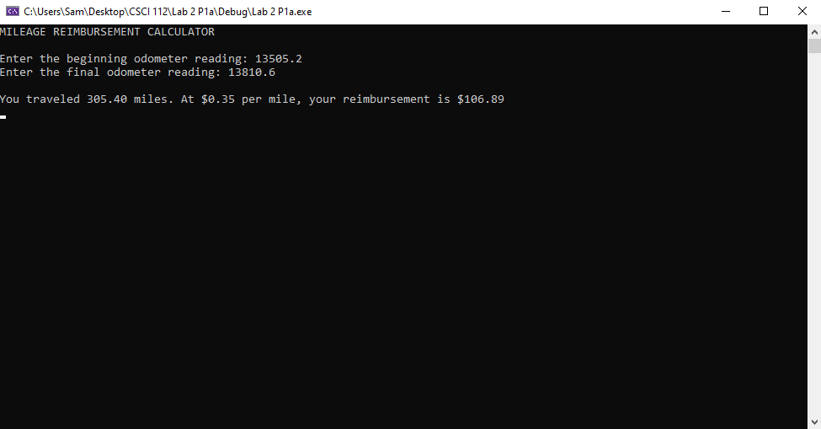

## Transcription:

MILEAGE REIMBURSEMENT CALCULATOR

Enter the beginning odometer reading: 13505.2

Enter the final odometer reading: 13810.6

You traveled 305.40 miles. At $0.35 per mile, your reimbursement is $106.89